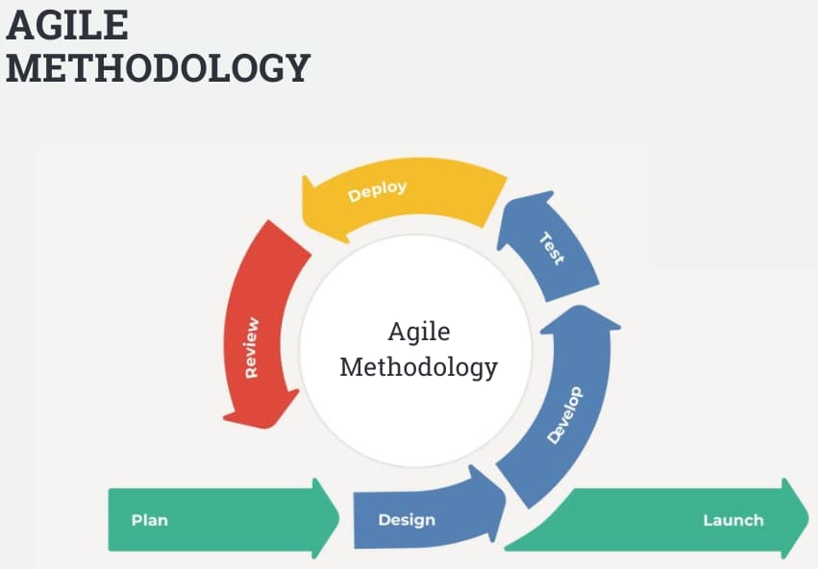

### **What Is Agile Methodology in Project Management?**

The Agile methodology is a way to manage a project by breaking it up into several phases. It involves constant collaboration with stakeholders and continuous improvement at every stage. Once the work begins, teams cycle through a process of planning, executing, and evaluating. Continuous collaboration is vital, both with team members and project stakeholders.